Analysing Parking systems’ potential to augment EV charging infrastructure.

Sujit Kumar Sikder, Magesh Nagarajan

**Project Goal:** Analysis of parking data to plan future e-mobility infrastructure

**Research Question (Tentative):**

1. What is the potential for developing charging infrastructure for a city by redeveloping public parking spaces?

# Introduction

Dresden is one of the largest cities in Germany with a resident population of 0.55 million with a density of 1700/km2 and a significant tourist attraction from other regions of Germany and Europe including from nearby the Czech Republic. With high population density and high day time occupancy in business and shopping districts due to intra-day mobility, parking spaces have been a priority for the local government and hence many multi-storey and ground level parking areas were identified, developed and operated with private stakeholders.

With the goal reducing carbon emission and promoting sustainable smart mobility, the city of Dresden aims to accelerate adoption of electric vehicles (EV). Unlike gasoline-based vehicles, electric vehicles require battery recharging on a regular interval with each recharge cycle takes substantially more time than refuelling a gasoline vehicle. This article aims to analyse the current usage pattern of parking spaces in the Dresden city and its potential to augment EV charging infrastructure.

In order to facilitate social transformation through digital knowledge, open data initiatives have received impetus from federal government with projects like “Open data foundation”. Sensors have been widely used to facilitate identification of available parking spaces and manage parking areas. Often these data have been used in real-time through apps (e.g. ParkenDD) and websites (<http://ubahn.draco.uberspace.de/opendata/ui/>) for drivers to locate nearest available parking facility. Having these easily accessible open data facilitates proactive travel planning including tourists and for managing traffic in highly congested zones. This parking usage open data has a potential to empirically measure the usage of parking spaces within Dresden and this will be one of the primary objectives of this work.

Preliminary analyses (in 2014) were conducted in an existing study on the parking usage during 2015 Christmas eve[1] for few parking areas. However, as of writing this article, comprehensive statistics were not available on inter-temporal and spatial variation of the parking usage patterns across the city was not linked to electric vehicles charging infrastructure. In addition, with recent growth in public and private operated EV charging infrastructure, the role of parking spaces need to analysed from its potential for installing EV charging points.

Figure 1 is a screenshot of public parking areas across the city of Dresden. It can be observed that the parking slots are indicated using colour codes like red (no free space), orange (limited free spaces), green (many spaces available) and blue (no real time data)[2].

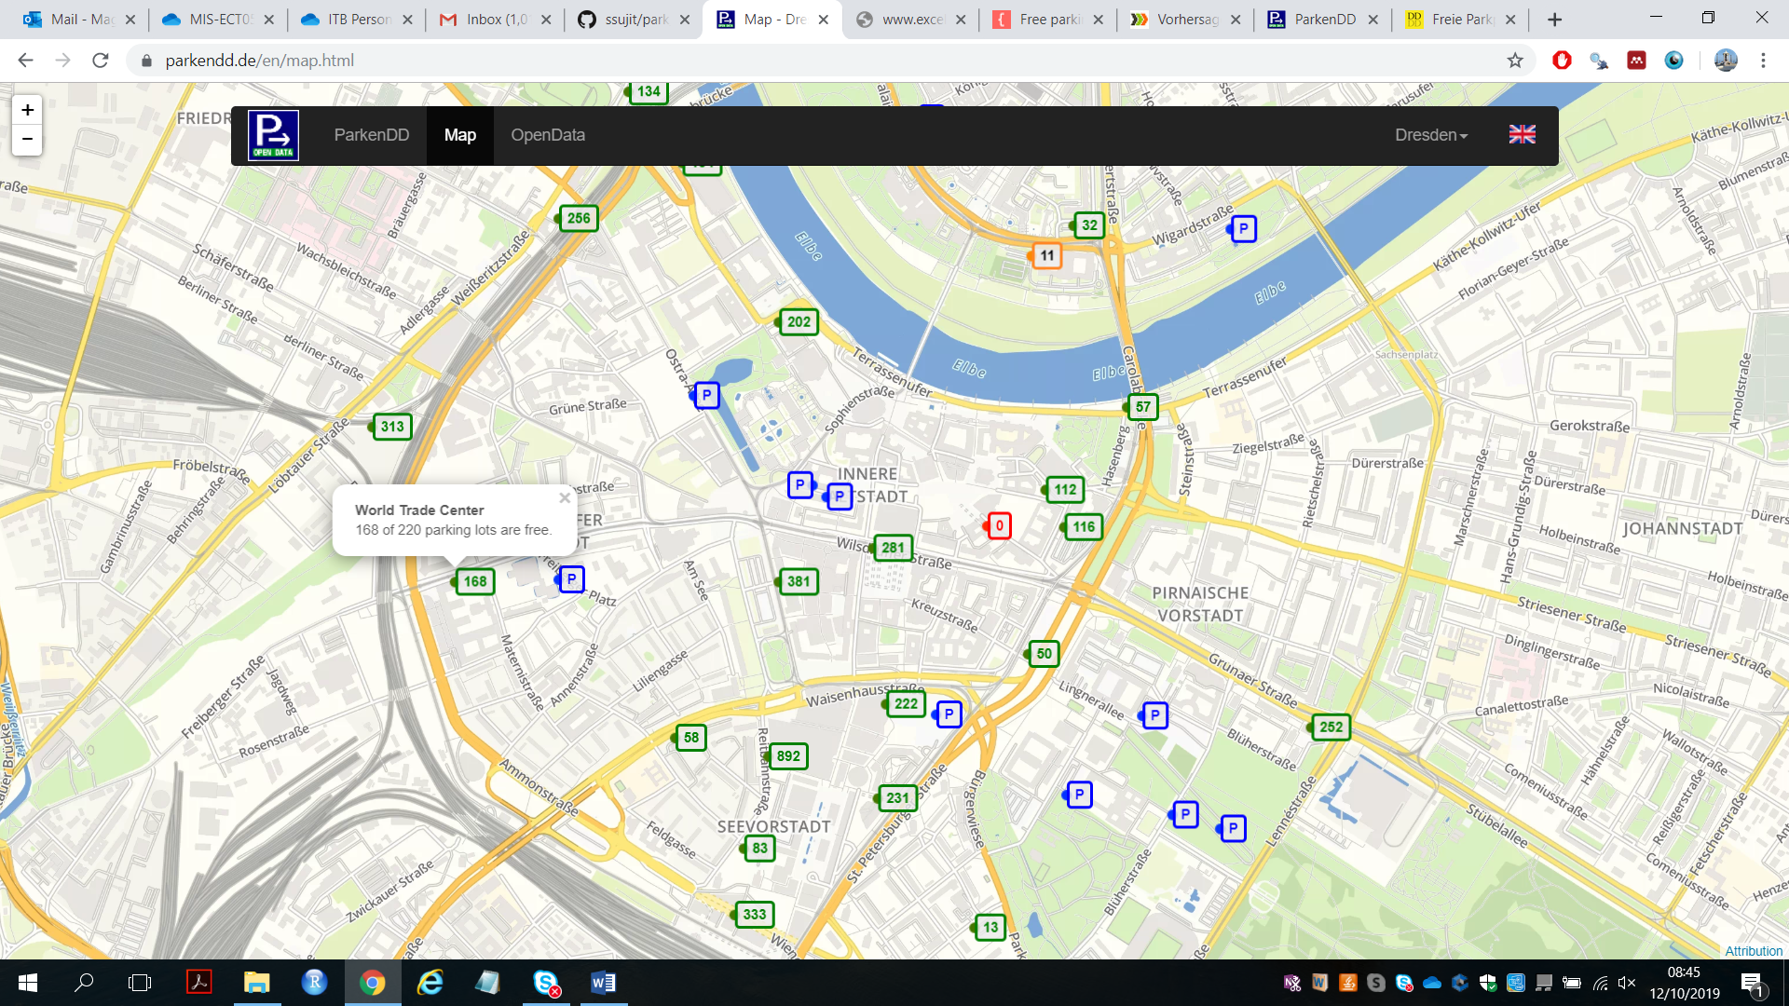

Figure Thematic map of parking areas in city of Dresden[3]

# Data sources:

ParkenDD has provided parking usage data for major public parking areas with sensors. These data was downloaded for XX54 parking locations in the city of Dresden for the years 2015 to 2018. Only the locations with all the three years have been included in this analyses and any recent development (in 2019) was not accessible for this study. For each parking area (e.g. World Trade Centre), the capacity (maximum vehicles that could be parked) along with free spaces currently available is displayed in the website. The sensors installed in these XX54 parking areas dispatch occupancy data on a scheduled 5 minutes interval to a central database. This dataset was used for comprehensive analyses in this study.

There could also be parking slots already used as EV charging points. The existing capacity could be further determined by overlaying E-cp data with ParkenDD data.

Analyses to be done

1. Analyse historic parking slot usage behave
   1. 34 location have full data for 4 years
2. Estimate at sub-regional level how many additional parking slots could be converted as e-cp points.
   1. Overlay e-cp data and parking data
   2. Overalay regional data (Dresden city has XX wards).
   3. Estimate existing capacity in each ward
   4. Estimate gaps

1. <https://mechlab-engineering.de/2015/03/vorhersage-der-parkhausbelegung-mit-offenen-daten/>
2. <https://www.dresden.de/apps_ext/ParkplatzApp/index;jsessionid=A764CD870ADC664536C57DDDAC6F4F18?0>
3. <https://parkendd.de/en/map.html>